Malaysian Applied Biology (2024) 53(x): xx-xx
https://doi.org/10.55230/mabjournal.xxxxxxx

Research Article
Comparative Physicochemical and Ultrastructural Characterization of Urinary Extracellular Vesicle-Enriched and Honey Vesicle-Like Nanoparticle Preparations

ABSTRACT
Extracellular vesicle (EV)-enriched preparations from human urine and vesicle-like nanoparticles from honey are accessible matrices for biomolecular and nanobiology research, but direct characterization across these sources remains limited. This descriptive study compared urinary and honey preparations generated by differential centrifugation, 0.22 µm filtration, and ultracentrifugation at 100,000 × g. Urine was obtained from three healthy donors under an approved urine-specific protocol, and three independent batches of wild forest honey were analyzed as non-human material. Characterization included dynamic light scattering (DLS), apparent zeta potential, Bradford total-protein assay, exploratory bead-based anti-human CD9/CD81 flow cytometry, and cryo-electron microscopy (cryo-EM). Urine preparations showed DLS Z-average values of 111.9–324.9 nm, whereas honey preparations showed 211.3–614.1 nm, indicating substantial intensity-weighted heterogeneity. Apparent zeta potentials measured in high-conductivity phosphate-buffered saline were approximately +0.1 mV for urine and −3.0 to −1.6 mV for honey and were therefore considered buffer-limited rather than intrinsic surface-charge estimates. Total protein concentrations in the final suspensions were 187.7 µg/mL for urine and 181.6 µg/mL for honey. Anti-human CD81-positive bead events were 20.0% in the urine preparation and 0.3% in the honey preparation; the latter assay is not validated for honey-derived particles and should not be used to infer vesicle identity. Cryo-EM demonstrated membrane-enclosed vesicular structures in both matrices. These findings provide a matrix-aware descriptive baseline while emphasizing the need for particle-number measurements, broader positive and negative marker panels, and source-appropriate assays before biological or therapeutic inferences are made.

Key words: cryo-electron microscopy, extracellular vesicles, honey, ultracentrifugation, urine, vesicle-like nanoparticles
INTRODUCTION
Extracellular vesicles (EVs) are membrane-enclosed particles released by cells and recovered from many biological fluids. Because physical separation procedures also recover non-vesicular particles and soluble macromolecules, current international guidance recommends operational terminology and orthogonal characterization rather than assigning a biogenesis-based EV subtype when biogenesis has not been demonstrated (Théry et al., 2018; Welsh et al., 2024). This distinction is especially important when complex matrices are compared using a common enrichment workflow.
Urine is a non-invasive source of human EV-associated material and is increasingly studied for biomarker discovery (Pisitkun et al., 2004; Gonzales et al., 2009; Oosthuyzen et al., 2013; Erdbrügger et al., 2021; Wang & Zhang, 2023), but urinary EV measurements are sensitive to collection, dilution, uromodulin, storage, and isolation procedures (Zhou et al., 2006; Kosanović & Janković, 2014; Musante et al., 2020; Erdbrügger et al., 2021). Honey is biologically and physicochemically distinct from human biofluids. Vesicle-like nanoparticles have been reported in honey and other bee products, with membrane-associated cargo and biological activities described in prior studies (Mu et al., 2014; Zhuang et al., 2015; Zhang et al., 2016; Schuh et al., 2019; Sundaram et al., 2019; Chen et al., 2021; Dad et al., 2021). Human tetraspanin assays, however, cannot be assumed to validate particles from honey because their epitope specificity is source dependent.
Direct, matrix-aware comparison of urinary EV-enriched and honey vesicle-like nanoparticle preparations remains limited. The present study therefore used the same broad enrichment framework—differential centrifugation, 0.22 µm filtration, and ultracentrifugation—followed by DLS, electrophoretic light scattering, total-protein quantification, exploratory bead-based anti-human CD9/CD81 flow cytometry, and cryo-EM. The objective was descriptive: to define physicochemical and ultrastructural characteristics of the two preparations and identify matrix-specific analytical limitations, without inferring EV purity, particle yield, therapeutic function, or biogenesis.

MATERIALS AND METHODS

Study design and ethical scope
This descriptive laboratory study compared preparations obtained from healthy-donor urine and commercial wild forest honey. The human-subject component was deliberately limited to urine collection, consistent with the scope of the available ethical approval. Urine was collected from three healthy donors after written informed consent. Honey comprised three independent harvest batches and was treated as non-human commercial material.

Urine collection
First-morning midstream urine was collected from healthy donors (n = 3) with no reported kidney or urinary tract disease, active urinary tract infection, pregnancy, or use of nephrotoxic medication. Donors were instructed to avoid strenuous exercise before collection. Samples were collected in sterile polypropylene containers, assessed visually and by routine urine quality measures, and processed promptly. Across donors, 150 mL of urine entered the enrichment workflow.

Honey material
Wild forest honey was obtained from Beezee Honey Indonesia and was produced by the giant honey bee Apis dorsata Fabricius, 1793 in a Central Java conservation forest. Three independent harvest batches (total starting volume, 150 mL) were used. The honey was supplied fresh and unprocessed, transported under cooled and light-protected conditions, and stored at 4 °C before processing.

Enrichment of urine and honey preparations
Low- and medium-speed centrifugation steps were performed using a Velocity 18R Pro refrigerated centrifuge. Ultracentrifugation was carried out using an Optima XPN-100 ultracentrifuge (Beckman Coulter, USA) equipped with an SW-41 Ti swinging-bucket rotor (k-factor 124) and thin-wall polypropylene tubes. Relative centrifugal force is reported as × g.
Urine was sequentially centrifuged at 400 × g for 10 min and 2,000 × g for 15 min at 20 °C. The supernatant was then centrifuged at 10,000 × g for 30 min at 20 °C, passed through a 0.22 µm polyethersulfone membrane filter, and ultracentrifuged at 100,000 × g for 90 min at 4 °C. Pelleted material was gently resuspended in phosphate-buffered saline (PBS). The cumulative final urine-preparation volume was 15 mL.
Honey was diluted 1:20 (v/v) in particle-filtered PBS (pH 7.4) containing protease inhibitor and gently mixed until homogeneous. Clarification comprised 400 × g for 10 min, 2,000 × g for 15 min, and 10,000 × g for 30 min at 20 °C, followed by 0.22 µm polyethersulfone filtration and ultracentrifugation at 100,000 × g for 90 min at 4 °C. Pelleted material was resuspended in PBS. The cumulative final honey-preparation volume was 14 mL. Final suspension volumes are reported only as operational handling volumes and were not interpreted as particle recovery or EV yield.

Particle size and apparent zeta potential
Hydrodynamic size distributions were measured by DLS using a HORIBA nanoPartica SZ-100V2 Series instrument at 25 °C. Samples were diluted in 0.22 µm-filtered PBS and technical runs were recorded for each matrix. The instrument reported intensity-weighted distributions, Z-average hydrodynamic diameter, and polydispersity index (PDI). Because DLS scattering is strongly influenced by larger particles, the Z-average was interpreted as a matrix-level intensity-weighted descriptor rather than a count-based particle-size distribution (Dragovic et al., 2011; van der Pol et al., 2014; Stetefeld et al., 2016; Welsh et al., 2024).
Electrophoretic light scattering was performed on the same instrument at 25 °C. Electrophoretic mobility was converted to zeta potential using the Smoluchowski approximation. Measurements were made in PBS with conductivity of approximately 16 mS/cm. High ionic strength compresses the electrical double layer; therefore, the results are reported as apparent zeta potential and are not interpreted as intrinsic vesicle surface charge.

Total protein quantification
Total protein in the final suspensions was measured by Bradford assay. Bovine serum albumin standards covered 10–160 µg/mL in five concentrations, each measured in technical triplicate. Samples and standards (5–20 µL) were combined with Bradford reagent to a final volume of 200 µL, incubated for 10 min at room temperature, and read at 595 nm using a Bio-Rad iMark microplate spectrophotometer. Sample concentrations were interpolated from the linear standard curve only within its analytical range. Total protein was not used as a surrogate for EV number or purity.

Exploratory bead-based flow cytometry
Tetraspanin-associated signal was explored using the Exosome Isolation and Analysis Kit – Flow Cytometry, Plasma (Abcam, Cambridge, UK; Cat. No. ab267479). Preparations were incubated overnight with 6.5 ± 0.2 µm polystyrene capture beads pre-coupled with anti-human CD9, blocked with the supplied assay buffer, and stained with PE-conjugated anti-human CD81 (clone M38) for 60 min at 2–8 °C. Unstained bead–sample tubes were used to set background. Isotype-matched, bead-only, and detergent-lysis controls were not available and this is treated as an analytical limitation.
Samples were analyzed on a BD FACSCanto II flow cytometer (BD Biosciences, USA) using FACSDiva version 6.1.3. A common sequence was applied: exclusion of debris by forward/side scatter, singlet selection, bead-event identification, and CD81 assessment in the PE channel. CD81-positive values represent percentages of events within the bead gate and not percentages of individual EVs (Welsh et al., 2020). The anti-human kit was adapted to urine and used only exploratorily for honey; it is not validated as an identity assay for honey-derived particles.

Cryo-electron microscopy
Morphology was examined using a 100 kV Tundra Cryo-TEM (Thermo Fisher Scientific). Samples (4 µL) were applied to glow-discharged 200-mesh copper grids with Lacey Formvar/Carbon support film. Grids were blotted in a Vitrobot Mark IV at approximately 4 °C and 100% relative humidity for 6 s at force level 3 and vitrified by plunging into liquid ethane. Representative micrographs were acquired at 180,000× magnification with an electron dose of 18.52 electrons/Å². Cryo-EM was used to document membrane-enclosed structures; it was not used to infer particle concentration, purity, or EV biogenesis (Yuana et al., 2013; Rikkert et al., 2019; Emelyanov et al., 2020; Welsh et al., 2024).

Data analysis
Analysis was descriptive. The available characterization dataset was reported at matrix level and consisted primarily of technical runs rather than donor- or batch-resolved characterization values. Technical runs were therefore not treated as independent biological replicates, and no inferential comparison between urine and honey was performed. Results are presented as observed ranges, concentrations, percentages, or representative instrument outputs as appropriate.

RESULTS

Particle size distribution
DLS demonstrated heterogeneous intensity-weighted particle distributions in both preparations. Urine showed Z-average values from 111.9 to 324.9 nm across available runs; the representative run shown in Figure 1(a) had a Z-average of 162.2 nm and PDI of 0.558. Honey showed Z-average values from 211.3 to 614.1 nm; the representative run shown in Figure 1(b) had a Z-average of 211.3 nm and PDI of 1.698, indicating marked heterogeneity. A small-size intensity mode near 58.3 nm accounted for approximately 22% of the area in one honey run, but DLS intensity weighting prevents interpretation of that area as a particle-number fraction.
Table 1. Dynamic light scattering results for urine and honey preparations
Source | Observed Z-average range (nm) | Interpretation of intensity-weighted profile
Urine | 111.9–324.9 | Heterogeneous; nanoscale and larger intensity contributions
Honey | 211.3–614.1 | Strongly heterogeneous; submicron signal dominated the intensity readout
Z-average values are intensity weighted. DLS does not provide absolute particle concentration and is disproportionately influenced by larger particles.
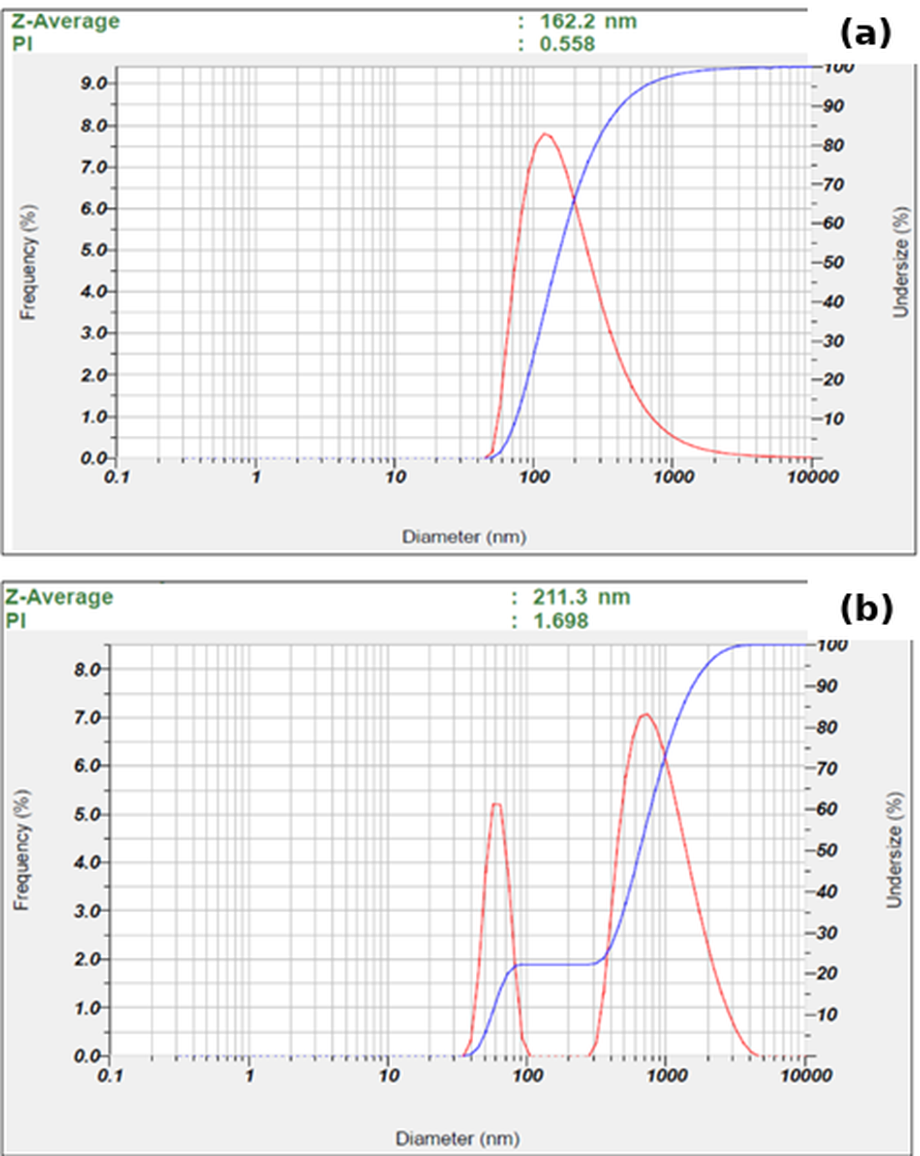
Fig. 1. Representative DLS intensity-weighted size distributions of (a) urine-derived EV-enriched and (b) honey-derived vesicle-like nanoparticle preparations. The representative urine run had a Z-average of 162.2 nm and PDI of 0.558; the representative honey run had a Z-average of 211.3 nm and PDI of 1.698.

Apparent zeta potential
The urine preparation showed an apparent zeta potential of approximately +0.1 mV, whereas the honey preparation ranged from −3.0 to −1.6 mV (Table 2; Figure 2). Conductivity was 16.628 mS/cm for the urine measurement and 15.996 mS/cm for honey. Because both measurements were made in high-conductivity PBS, these low-magnitude values were treated as buffer-limited observations rather than intrinsic surface-charge estimates.
Table 2. Apparent zeta-potential measurements
Source | Apparent zeta potential (mV) | Conductivity (mS/cm) | Electrophoretic mobility (cm²/V·s)
Urine | ~+0.1 | 16.628 | approximately 0
Honey | −3.0 to −1.6 | 15.996 | −0.000023 to −0.000013
Measurements were performed in PBS at high conductivity; values should not be interpreted as intrinsic vesicle surface charge.
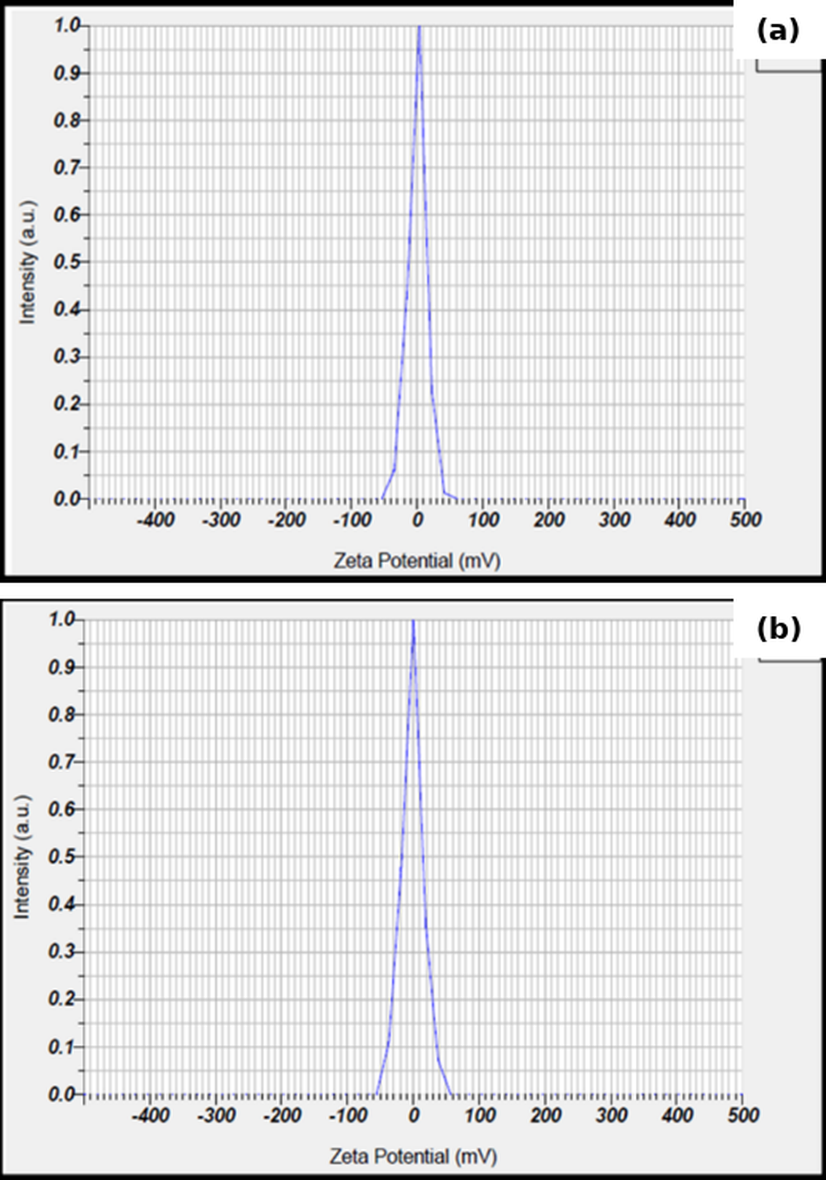
Fig. 2. Representative apparent zeta-potential distributions of (a) urine and (b) honey preparations measured by electrophoretic light scattering in PBS. High buffer conductivity limits interpretation of the absolute values.

Total protein
The Bradford standard curve was linear over the working range (y = 0.00193x + 0.0107; R² = 0.989; Figure 3). Total protein concentration in the final suspension was 187.7 µg/mL for urine and 181.6 µg/mL for honey. Based on the cumulative final suspension volumes, this corresponded to 2.82 mg and 2.54 mg total recovered protein, respectively (Table 3). These values quantify protein in the enriched preparations and do not distinguish vesicle-associated protein from co-isolated soluble or non-vesicular protein.
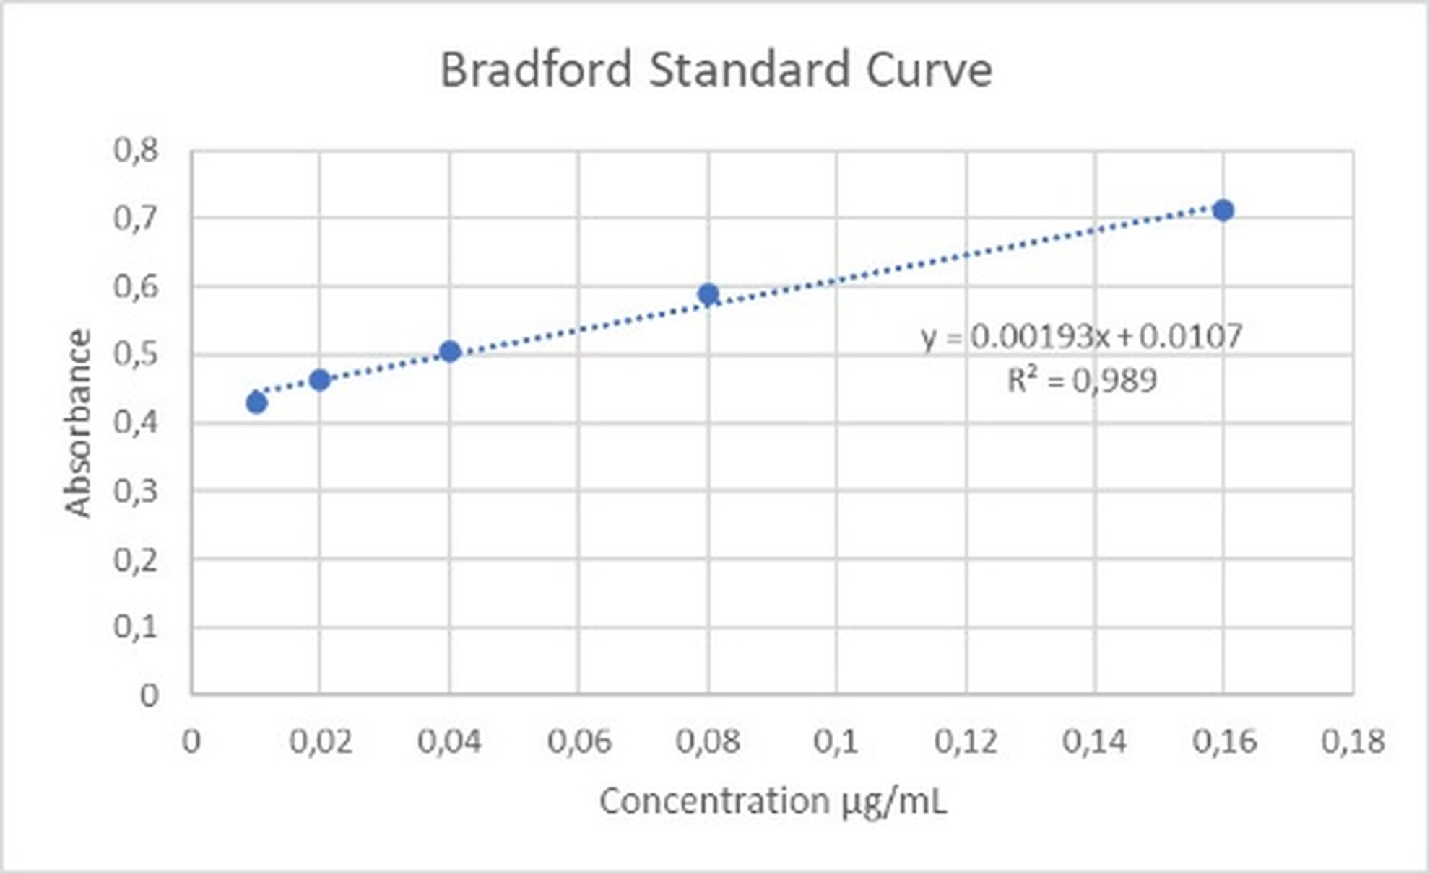
Fig. 3. Bovine serum albumin Bradford standard curve used for total-protein quantification (10–160 µg/mL; y = 0.00193x + 0.0107; R² = 0.989).
Table 3. Total protein in urine and honey preparations
Source | Initial volume (mL) | Final suspension volume (mL) | Total protein concentration (µg/mL) | Total recovered protein (mg) | Protein normalized to initial volume (µg/mL)
Urine | 150 | 15 | 187.7 | 2.82 | 18.8
Honey | 150 | 14 | 181.6 | 2.54 | 17.0
Protein values characterize the final enriched suspensions and are not measures of EV particle number or purity.

Anti-human CD81 signal in bead-based flow cytometry
Unstained controls showed low background within the bead gate: 0.1% CD81-positive events for urine and 0.0% for honey. After staining, the urine preparation showed 20.0% CD81-positive bead events by the prespecified dot-plot gate (19.3% by the available histogram gate), whereas honey showed 0.3% by both readouts (Table 4; Figure 4). Upstream singlet and bead gating retained substantial event populations in both matrices.
Table 4. Bead-based flow-cytometry gating and anti-human CD81 signal
Source | Staining | All events (n) | Non-debris (% total) | Singlets (% parent) | Beads (% parent) | CD81-positive beads (% bead gate)
Urine | Unstained | 15,840 | 60.6 | 94.1 | 87.6 | 0.1
Urine | Stained | 72,039 | 48.8 | 95.1 | 79.7 | 20.0
Honey | Unstained | 10,395 | 63.6 | 96.2 | 91.9 | 0.0
Honey | Stained | 38,016 | 56.5 | 95.2 | 85.7 | 0.3
Percentages follow the instrument/software hierarchy. CD81-positive values are percentages of bead-gated events, not percentages of individual EVs. The anti-human CD9/CD81 assay is not validated for honey-derived particles.
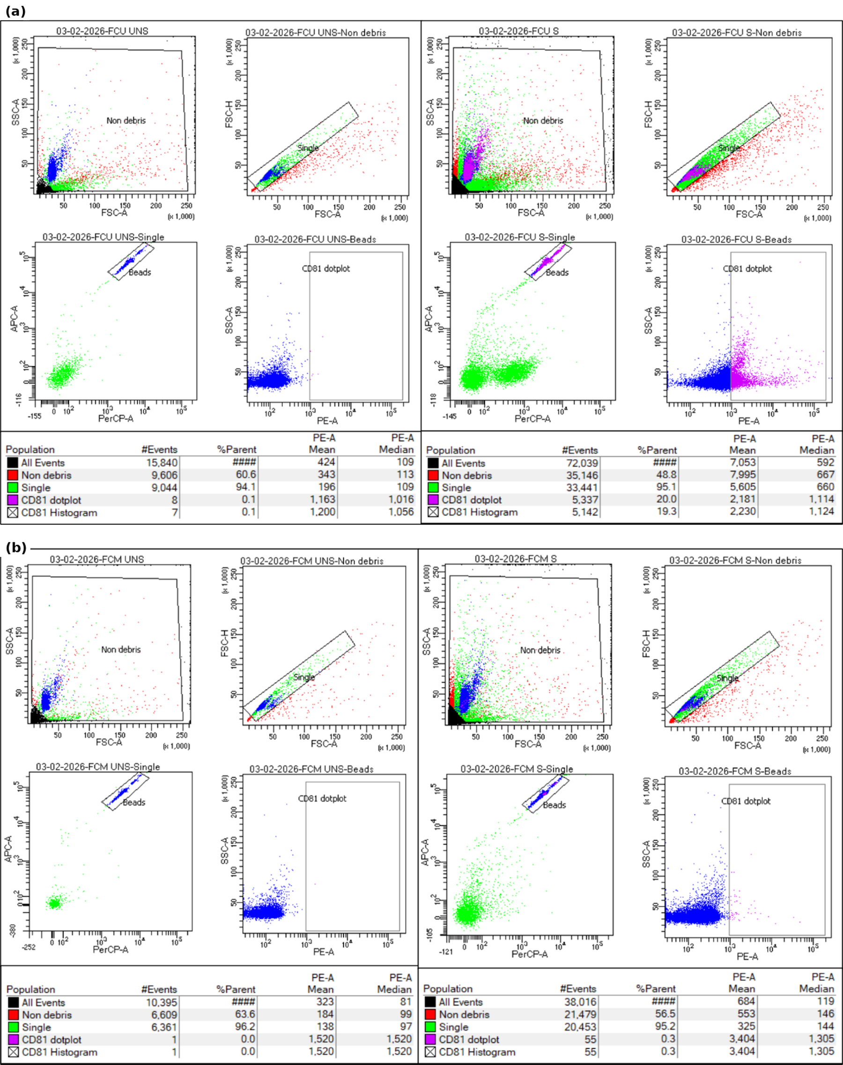
Fig. 4. Representative bead-based flow-cytometry gating and anti-human CD81-PE detection in (a) urine and (b) honey preparations, comparing unstained (UNS) and stained (S) tubes. The sequence comprised non-debris gating, singlet selection, bead-event identification, and CD81 assessment. The assay is not validated as an identity test for honey-derived particles.

Cryo-electron microscopy
Cryo-EM showed rounded or ovoid membrane-enclosed vesicular structures in both preparations (Figure 5). Representative fields contained structures in the nanoscale range, with no attempt to derive a quantitative diameter distribution from the selected micrographs. These observations establish the presence of membrane-enclosed material in the preparations but do not establish particle concentration, purity, or biogenesis-based EV subtype.
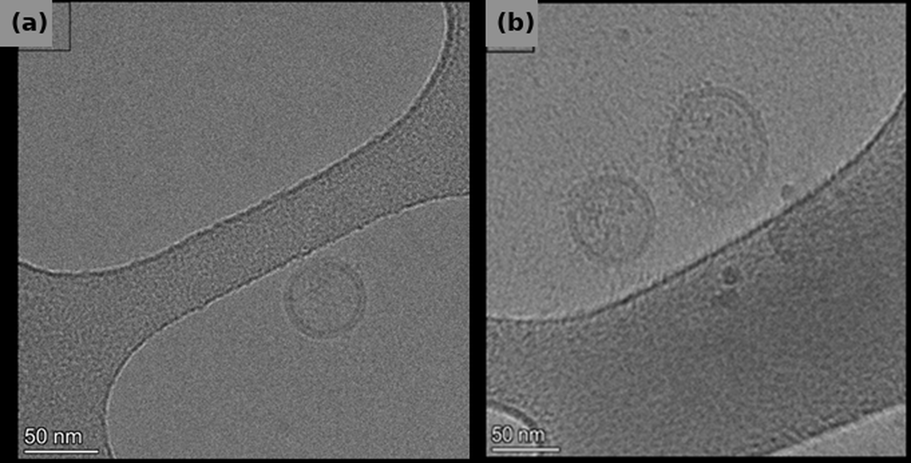
Fig. 5. Representative cryo-electron micrographs of (a) honey and (b) urine preparations showing membrane-enclosed vesicular structures in vitreous ice. Scale bars = 50 nm.

DISCUSSION
The present comparison demonstrates that a common enrichment framework can recover membrane-enclosed, nanoscale-to-submicron material from both urine and honey, while also showing why matrix-specific interpretation is essential. The strongest evidence common to the two preparations was morphological: cryo-EM directly demonstrated membrane-enclosed structures. DLS and total-protein measurements complemented that evidence but could not establish EV identity or purity on their own. This interpretation follows MISEV2023 principles, which emphasize multiple orthogonal readouts and explicit acknowledgement of method-specific limitations (Welsh et al., 2024).
Urine showed a broad DLS range despite a representative nanoscale peak. This is plausible for urinary preparations because concentration, storage, urinary proteins, and uromodulin can alter aggregation and recovery (Erdbrügger et al., 2021; Wang & Zhang, 2023). DLS is also intrinsically biased toward larger scatterers, so a modest amount of aggregated or larger material can markedly shift the intensity-weighted Z-average. The reported values should therefore be read as preparation-level physical descriptors, not as the median diameter of individual vesicles. A single-particle method such as nanoparticle tracking analysis or another validated particle-counting approach would be required to obtain a particle concentration and count-based size distribution.
Honey was even more heterogeneous by DLS, with a PDI of 1.698 in the representative run and Z-average values extending into the submicron range. This does not negate the cryo-EM observation of membrane-enclosed nanoscale structures; rather, it indicates that the suspension also contained larger or aggregated material that dominated intensity-weighted scattering. Prior studies have reported vesicle-like nanoparticles in honey and bee products, but such particles should be described using source-aware terminology and characterized independently of mammalian EV markers (Schuh et al., 2019; Chen et al., 2021).
The zeta-potential experiment provides a further example of an analytical limitation that can otherwise be overinterpreted. Both matrices were measured in PBS with conductivity close to 16 mS/cm. Under these conditions, compression of the electrical double layer makes the near-neutral apparent values unsuitable as intrinsic surface-charge measurements. A future experiment should use a validated low-conductivity dispersant and explicitly report ionic strength, pH, conductivity, and dilution conditions.
Total protein concentrations were similar in the final urine and honey suspensions, but protein quantity cannot be equated with particle number. Urinary preparations can contain uromodulin and soluble proteins, whereas honey contains abundant non-vesicular biomolecules. Future work should pair particle counts with protein measurements and evaluate matrix-specific contaminants to estimate particle-to-protein relationships more meaningfully (Erdbrügger et al., 2021; Welsh et al., 2024).
The bead-based flow-cytometry findings require particularly cautious interpretation. The urine preparation produced a clear anti-human CD81-associated signal over its unstained control, consistent with capture of human tetraspanin-bearing material; however, the method used bead capture and does not directly enumerate single EVs. The honey result cannot be interpreted with the same biological meaning. The kit uses anti-human CD9 capture and anti-human CD81 detection and was developed for human plasma. The 0.3% signal in honey is therefore best regarded as assay background or limited cross-reactivity rather than evidence for or against honey vesicle identity. Source-appropriate molecular or lipid markers are needed for honey-derived nanoparticles.
This study has several limitations. Characterization results were available at matrix level rather than as donor- or batch-resolved biological replicates, precluding inferential comparisons. Absolute particle concentration was not measured. The marker panel lacked additional transmembrane and cytosolic EV-associated proteins as well as negative or contaminant markers, and isotype, bead-only, and detergent-lysis controls were not available for flow cytometry. Cryo-EM was qualitative and did not include systematic diameter measurements. Finally, no loading, uptake, toxicity, or bioactivity assays were performed; consequently, the present data do not establish diagnostic or drug-delivery utility. These limitations define specific priorities for a subsequent validation study.
Despite these constraints, the work provides a useful descriptive comparison of two accessible but biologically distinct matrices using the same broad isolation workflow. Similar comparative characterization has been used to optimize EV methods in human serum, including within Malaysian Applied Biology (Sou et al., 2025). Here, the principal contribution is not demonstration of equivalence between urine and honey, but identification of how measurement interpretation changes across a human biofluid and a complex non-human natural product.
CONCLUSION
Urine and honey yielded enriched preparations containing membrane-enclosed vesicular structures, but their physicochemical profiles and analytical interpretability differed substantially. Urine showed a clearer anti-human CD81-associated bead signal, whereas the human tetraspanin assay was not suitable for validating honey-derived particles. DLS demonstrated marked heterogeneity, particularly in honey, and zeta-potential values obtained in high-conductivity PBS were buffer limited. The findings should therefore be regarded as a descriptive characterization baseline rather than evidence of EV purity, particle yield, biological function, or therapeutic suitability. Future studies should incorporate donor- and batch-resolved measurements, absolute particle counting, broader positive and negative marker panels, low-conductivity zeta-potential conditions, quantitative cryo-EM analysis, and source-appropriate honey markers before functional applications are evaluated.
ACKNOWLEDGEMENTS
This work was supported by Kementerian Pendidikan Tinggi, Sains, dan Teknologi Republik Indonesia through the BIMA Fundamental Research Grant (Decree No. 0419/C3/DT.05.00/2025; Grant Agreement No. 124/C3/DT.05.00/PL/202). Institutional and technical acknowledgements that could identify the authors are withheld from the blinded manuscript and will be restored after peer review.
ETHICAL STATEMENT
The human-subject component of this study was limited to urine collection from healthy donors. Urine donor procedures were conducted in accordance with the Declaration of Helsinki. This component was approved by the Medical and Health Research Ethics Committee, Faculty of Medicine and Health Sciences, Krida Wacana Christian University (Approval No. 1939/SLKE/IM/UKKW/FKIK/KEPK/III/2025; 27 March 2025) under the protocol “Isolation and identification of extracellular vesicles from healthy donor urine.” Written informed consent was obtained from all urine donors before sample collection. Honey was a commercial non-human material and did not require human-subject ethics approval.
CONFLICT OF INTEREST
The authors declare no conflict of interest.
REFERENCES
Chen, X., Liu, B., Li, X., An, T.T., Zhou, Y., Li, G., et al. 2021. Identification of anti-inflammatory vesicle-like nanoparticles in honey. Journal of Extracellular Vesicles, 10(4): e12069. https://doi.org/10.1002/jev2.12069
Dad, H.A., Gu, T.W., Zhu, A.Q., Huang, L.Q. & Peng, L.H. 2021. Plant exosome-like nanovesicles: Emerging therapeutics and drug delivery nanoplatforms. Molecular Therapy, 29(1): 13–31. https://doi.org/10.1016/j.ymthe.2020.11.030
Dragovic, R.A., Gardiner, C., Brooks, A.S., Tannetta, D.S., Ferguson, D.J.P., Hole, P., et al. 2011. Sizing and phenotyping of cellular vesicles using nanoparticle tracking analysis. Nanomedicine: Nanotechnology, Biology and Medicine, 7(6): 780–788. https://doi.org/10.1016/j.nano.2011.04.003
Emelyanov, A., Shtam, T., Kamyshinsky, R., Garaeva, L., Verlov, N., Miliukhina, I., Kudrevatykh, A., Gavrilov, G., Zabrodskaya, Y., Pchelina, S. & Konevega, A.L. 2020. Cryo-electron microscopy of extracellular vesicles from cerebrospinal fluid. PLoS ONE, 15(1): e0227949. https://doi.org/10.1371/journal.pone.0227949
Erdbrügger, U., Blijdorp, C.J., Bijnsdorp, I.V., Borràs, F.E., Burger, D., Bussolati, B., et al. 2021. Urinary extracellular vesicles: A position paper by the Urine Task Force of the International Society for Extracellular Vesicles. Journal of Extracellular Vesicles, 10(7): e12093. https://doi.org/10.1002/jev2.12093
Gonzales, P.A., Pisitkun, T., Hoffert, J.D., Tchapyjnikov, D., Star, R.A., Kleta, R., et al. 2009. Large-scale proteomics and phosphoproteomics of urinary exosomes. Journal of the American Society of Nephrology, 20(2): 363–379. https://doi.org/10.1681/ASN.2008040406
Kosanović, M. & Janković, M. 2014. Isolation of urinary extracellular vesicles from Tamm-Horsfall protein-depleted urine and their application in the development of a lectin-exosome-binding assay. BioTechniques, 57(3): 143–149. https://doi.org/10.2144/000114208
Mu, J., Zhuang, X., Wang, Q., Jiang, H., Deng, Z.B., Wang, B., et al. 2014. Interspecies communication between plant and mouse gut host cells through edible plant derived exosome-like nanoparticles. Molecular Nutrition & Food Research, 58(7): 1561–1573. https://doi.org/10.1002/mnfr.201300729
Musante, L., Bontha, S.V., La Salvia, S., Fernandez-Piñeros, A., Lannigan, J., Le, T.H., et al. 2020. Rigorous characterization of urinary extracellular vesicles (uEVs) in the low centrifugation pellet - a neglected source for uEVs. Scientific Reports, 10(1): 3701. https://doi.org/10.1038/s41598-020-60619-w
Oosthuyzen, W., Sime, N.E.L., Ivy, J.R., Turtle, E.J., Street, J.M., Pound, J., et al. 2013. Quantification of human urinary exosomes by nanoparticle tracking analysis. The Journal of Physiology, 591(23): 5833–5842. https://doi.org/10.1113/jphysiol.2013.264069
Pisitkun, T., Shen, R.F. & Knepper, M.A. 2004. Identification and proteomic profiling of exosomes in human urine. Proceedings of the National Academy of Sciences of the United States of America, 101(36): 13368–13373. https://doi.org/10.1073/pnas.0403453101
Rikkert, L.G., Nieuwland, R., Terstappen, L.W.M.M. & Coumans, F.A.W. 2019. Quality of extracellular vesicle images by transmission electron microscopy is operator and protocol dependent. Journal of Extracellular Vesicles, 8(1): 1555419. https://doi.org/10.1080/20013078.2018.1555419
Schuh, C.M.A.P., Aguayo, S., Zavala, G. & Khoury, M. 2019. Exosome-like vesicles in Apis mellifera bee pollen, honey and royal jelly contribute to their antibacterial and pro-regenerative activity. Journal of Experimental Biology, 222(20): jeb208702. https://doi.org/10.1242/jeb.208702
Sou, Y.L., Tan, P.P.S., Muhamad Hendiri, N.A., Ratnam, W., Karupaiah, T., Chilian, W.M., Mohd Zain, S., Syed Abdul Kadir, S.Z., Pan, Y. & Pung, Y.F. 2025. Evaluation of small extracellular vesicles isolation methods from human serum for downstream miRNA profiling. Malaysian Applied Biology, 54(1): 98–107. https://doi.org/10.55230/mabjournal.v54i1.3357
Stetefeld, J., McKenna, S.A. & Patel, T.R. 2016. Dynamic light scattering: A practical guide and applications in biomedical sciences. Biophysical Reviews, 8(4): 409–427. https://doi.org/10.1007/s12551-016-0218-6
Sundaram, K., Miller, D.P., Kumar, A., Teng, Y., Sayed, M., Mu, J., et al. 2019. Plant-derived exosomal nanoparticles inhibit pathogenicity of Porphyromonas gingivalis. iScience, 21: 308–327. https://doi.org/10.1016/j.isci.2019.10.032
Théry, C., Witwer, K.W., Aikawa, E., Alcaraz, M.J., Anderson, J.D., Andriantsitohaina, R., et al. 2018. Minimal information for studies of extracellular vesicles 2018 (MISEV2018): A position statement of the International Society for Extracellular Vesicles and update of the MISEV2014 guidelines. Journal of Extracellular Vesicles, 7(1): 1535750. https://doi.org/10.1080/20013078.2018.1535750
van der Pol, E., Coumans, F.A.W., Grootemaat, A.E., Gardiner, C., Sargent, I.L., Harrison, P., et al. 2014. Particle size distribution of exosomes and microvesicles determined by transmission electron microscopy, flow cytometry, nanoparticle tracking analysis, and resistive pulse sensing. Journal of Thrombosis and Haemostasis, 12(7): 1182–1192. https://doi.org/10.1111/jth.12602
Wang, Y. & Zhang, M. 2023. Urinary exosomes: A promising biomarker for disease diagnosis. Laboratory Medicine, 54(2): 115–125. https://doi.org/10.1093/labmed/lmac087
Welsh, J.A., van der Pol, E., Arkesteijn, G.J.A., Bremer, M., Brisson, A., Coumans, F., et al. 2020. MIFlowCyt-EV: A framework for standardized reporting of extracellular vesicle flow cytometry experiments. Journal of Extracellular Vesicles, 9(1): 1713526. https://doi.org/10.1080/20013078.2020.1713526
Welsh, J.A., Goberdhan, D.C.I., O’Driscoll, L., Buzas, E.I., Blenkiron, C., Bussolati, B., et al. 2024. Minimal information for studies of extracellular vesicles (MISEV2023): From basic to advanced approaches. Journal of Extracellular Vesicles, 13(2): e12404. https://doi.org/10.1002/jev2.12404
Yuana, Y., Koning, R.I., Kuil, M.E., Rensen, P.C.N., Koster, A.J., Bertina, R.M. & Osanto, S. 2013. Cryo-electron microscopy of extracellular vesicles in fresh plasma. Journal of Extracellular Vesicles, 2: 21494. https://doi.org/10.3402/jev.v2i0.21494
Zhang, M., Viennois, E., Prasad, M., Zhang, Y., Wang, L., Zhang, Z., et al. 2016. Edible ginger-derived nanoparticles: A novel therapeutic approach for the prevention and treatment of inflammatory bowel disease and colitis-associated cancer. Biomaterials, 101: 321–340. https://doi.org/10.1016/j.biomaterials.2016.06.018
Zhou, H., Yuen, P.S.T., Pisitkun, T., Gonzales, P.A., Yasuda, H., Dear, J.W., et al. 2006. Collection, storage, preservation, and normalization of human urinary exosomes for biomarker discovery. Kidney International, 69(8): 1471–1476. https://doi.org/10.1038/sj.ki.5000273
Zhuang, X., Deng, Z.B., Mu, J., Zhang, L., Yan, J., Miller, D., et al. 2015. Ginger-derived nanoparticles protect against alcohol-induced liver damage. Journal of Extracellular Vesicles, 4: 28713. https://doi.org/10.3402/jev.v4.28713

